Automate population of table XXMX_dm_asset_books_in_scope

Purpose of the integration:

This document covers the documentation for “INTDM99999 XXMX_DM_ASSET_BOOKS_IN_SCOPE” which is used to populate data into table XXMX_dm_asset_books_in_scope

Requirement : To insert the ledger, BU, ledger_id data into “XXMX_dm_asset_books_in_scope” table for the current environment which could be utilized in integrations for the data migration.

Problem Statement:

Earlier, table was populated manually for each new environment setup.

Solution :

A new report has been created with below path which would be consumed in the scheduled integration. Integration would run each time before GL transformation.

Steps Involved:

Table will be truncated🡪Report will be called🡪Stage Write operation is called using opaque XSD schema for the base64 format report output received from “Report”🡪 Read stage operation is used to convert the file reference received from “Stage Write operation “in CSV format having ledger and access details 🡪 Table will be populated with the read response.

Below is the screen shot for the same.

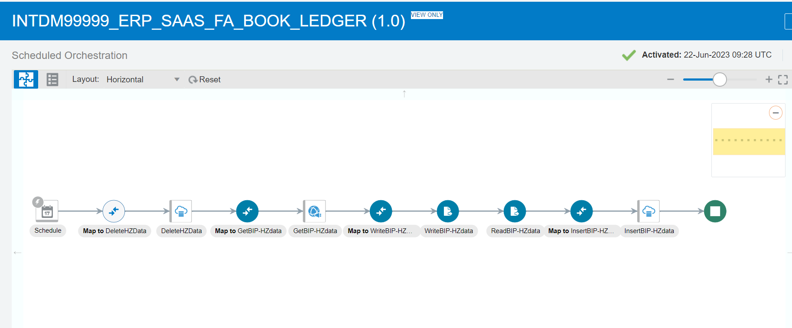

Report: /Custom/Maximise Data Migration/Reference Data Reports/XXMX FA BOOK LEDGER REPORT.xdo”

Data Model: /Custom/Maximise Data Migration/Reference Data Reports/XXMX FA BOOK LEDGER DM”